Jeffrey P. Gonsalves, AMS
220 Smith Neck Road
S. Dartmouth, MA 02748
Master 100T  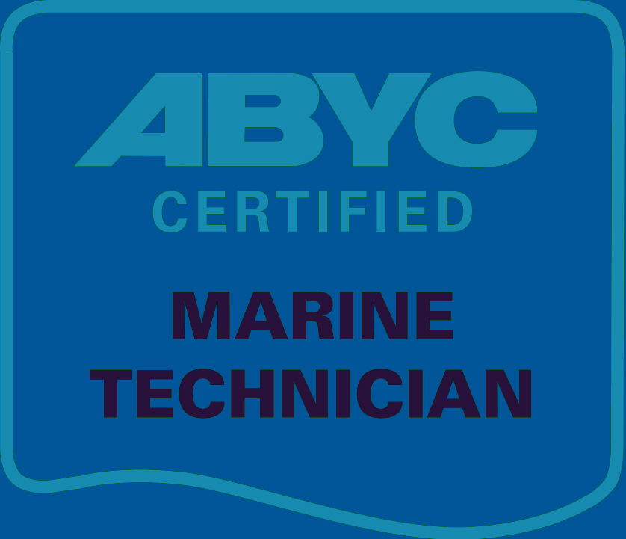

MARINE SURVEY REPORT – BENETEAU SENSE 55

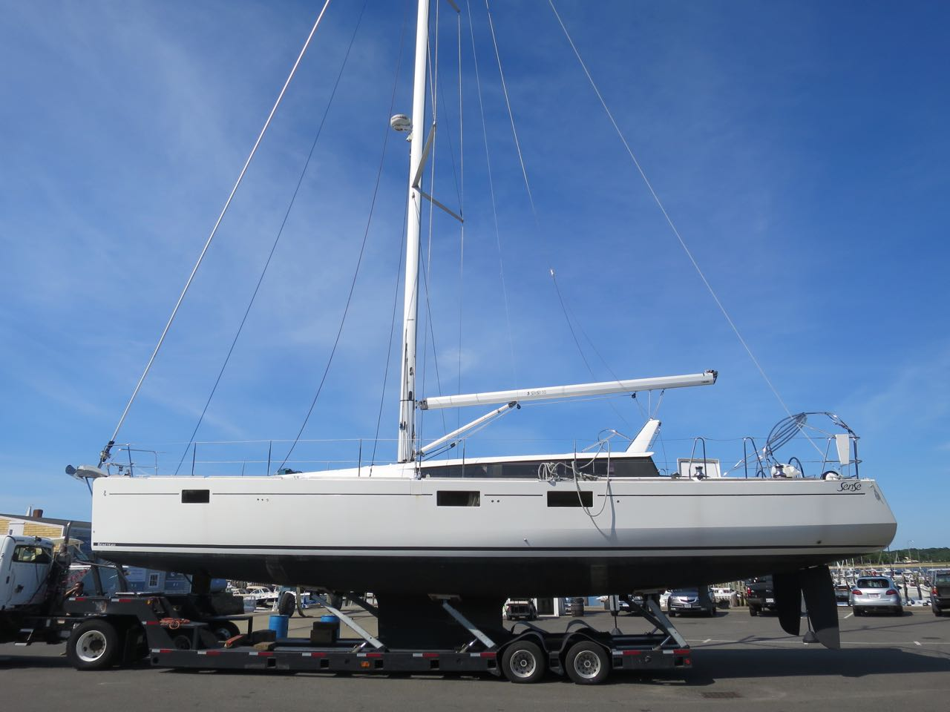

Confidential Report prepared exclusively for
Johan Hedlund

Date: 7.10.2018 File: 1048

MARINE SURVEY REPORT

For: Mr. Johan R. Hedlund Vessel Name:
23 Butterville Road Survey Date: 7.9.2018
New Paltz, NY 12561-2800 Location: Blocked on stands and afloat,
South Wharf Yacht Yard, S Dartmouth, MA
Reg.No.: H.I.N.: BEYDL056G415
Doc. #: Hail Port:
Vessel's Owner: Beneteau

VESSEL DESCRIPTION
Type of Vessel: Beneteau Sense 55, diesel auxiliary sloop
Style & Color: Fin keel w/ bulb, white topsides, blue bootstripe, black bottom
L.O.A.: 56’5" L.W.L.: 52’3" Beam: 16’4” Draft: 5’11”
Gross Reg. Tons: 15 Displacement: 40,918 LBS
Designer: Berret-Racoupeau/Nauta Design
Builder: Beneteau Yachts, France
Year Built: 2015 Rebuilt:
Navigational Limits: None

Scope of survey: This survey is an examination of the vessel’s structure, equipment and systems utilizing percussion sounding, moisture testing and visual inspection of the operation of the engine, equipment and systems. All areas readily accessible without the use of tools were inspected; no destructive inspection methods were used. A Protimeter Aquant was used to test moisture. This was a pre-purchase survey performed on land and in the water with a sea trial in which all systems were tested.

HULL, DECK & SUPER STRUCTURE
Construction: Hull is machine and hand laminated single skin F.R.P. bonded with internal structural grid with incorporated FRP floors. Deck is balsa core hand laminated F.R.P. Interior is molded FRP pan liner. Hull to deck joint is shoebox type in-turning flange glued and bolted. This is strong construction in very good condition.
This vessel is well suited to its intended purpose of coastal and extended cruising.

Deck: I sounded, visually inspected and moisture metered all and found no blisters, voids, delaminations or any other signs of damage. Teak overlay in cockpit in good condition.

Bottom: I sounded, visually inspected and moisture metered all and found no blisters, voids, delaminations or any other signs of damage. Bottom paint is in good condition – bottom paint in need of routine seasonal prep and paint.

Exterior Finish: Topsides gelcoat is in good condition with a one minor scratch/gouge into the gelcoat on the port side aft; deck gelcoat and nonskid is in very good condition with a few minor cosmetic surface gelcoat cracks in the area by the mast step and along the self-tacking jib track. Exterior teak trim is bare and in good condition in need of normal routine cleaning and finish as desired.

Keel: External cast iron fin with bulb, bolted to hull, good condition. S/S keel bolts in good condition where sited in bilge.

Ballast: 12,125 Lbs. cast iron.

Centerboard\Trunk: None

Anodes: Sacrificial anodes on thruster props, collar anode on saildrive and cone anode on prop – new anode installed on prop – renew collar anode on saildrive and cone anodes on bowthruster as necessary.
SAILS & RIG (mast in – lower inspection only)
Spars: Selden Spars anodized aluminum mast w/roller furler in cavity, 2 sets swept back aluminum spreaders, boom and Selden Rod Kicker rigid vang in very good condition where sited.
Mast lights: Foredeck light, steaming light and anchor light –steaming and foredeck light working – could not see anchor light.
Furling Headstay: Facnor model LS290, good condition where sited.
Standing Rigging: 1x19 S/S wire, S/S swage end fittings, chromed bronze open barrel turnbuckles, very good condition where sited.
Running Rigging: Braided sheets and Dyneema halyards in very good condition where sited.
Mast step: Aluminum on deck with dual S/S compression posts onto FRP structural grid below in good condition.
Winches: Harken (2) #60ST electric 2-speed, (2) #46ST 2-speed secondaries on combing, good condition – tested and working, recommend routine service annually.
Deck Hardware: Lewmar mainsheet blocks on arch and Harken blocks on boom, Harken adjustable jib cars, Selden bullet blocks at mast and Harken deck blocks; Lewmar line clutches, all in good condition with the exception of one line clutch on portside. See Notes.
Chainplates: S/S fabrication bolted to hull side structural reinforcements. Strong construction in good condition, no sign of leaks. See Notes.
Sails: In mast furling Neil Pryde mainsail and 100% RF genoa, like new condition.
Canvas: Graphite Sunbrella dodger and bimini in good to very good condition – minor zipper repair needed on starboard side dodger. See Notes.

HARDWARE & EQUIPMENT
Stanchions and Lifelines: S/S tube bowrail, tapered stanchions, split stern rail to transom scoop w/fold-down swim ladder, double S/S wire lifelines in very good condition.
Hatches/ Portlights: Lewmar hatches and Lewmar opening ports and fixed ports in very good condition. Ocean Air retractable hatch screens and shades operable in good condition except port forward shower stall hatch screen - See Notes.
Ground tackle: 32kg Delta plow w/250’ 7/16” all chain rode, very good condition.
Chocks and Cleats: Cast aluminum, very good condition
Anchor Windlasses: Lewmar V5 12-volt horizontal capstan and gypsy, tested and working. Quick chain counter and windlass control at helm station – not working - See Notes.
Compass: (2) 5” Plastimo Olympic 135s on pedestals, very good condition.
Misc.: Folding/electric telescoping teak cockpit table, good condition, tested and working.
Hinged swing away corner helm seats and retractable pocket transom board for open cockpit.
Noval electric telescoping companionway hatch boards – See Notes.

ELECTRONICS
Radios: Raymarine RayMic260, S/N A801961030151, tested and working. (no wireless handheld for cockpit onboard)
G.P.S. (3) Raymarine e125 multifunction display at nav station and twin e95 MFDs at each helm station, tested and working.
Radar: (3) Raymarine e9 multifunction displays w/4KW HD radome antenna, tested and working.
Fathometer: Raymarine i70 display – port helm, tested and working.
Wind Inst.: Raymarine i70 display – starboard helm, tested and working.
Speed\Log: Raymarine i70 display – port helm, tested and working.
Autopilot: Raymarine Autohelm p70 display and wireless Smart Controler w/linear drive and ACU-400 actuator control unit, tested and working.
Misc: Raymarine AIS650 Class B transceiver, tested and working.
SAFETY EQUIPMENT - See Notes.

P.F.D. Type, No.: 4 Type II adult
Life Rings, M.O.M., Poles, etc.: Type IV throwable cushion; sternrail Lifering holder is bent - See Notes.
Life Rafts: None – molded FRP bin between helm stations for liferaft storage.
Portable Extinguishers: Kidde ABC model H110G and Kidde BC model FA10G in starboard cockpit locker. Equip boat with USCG prescribed number of fire extinguishers – recommend mounting portable extinguishers in accessible locations on interior by forward cabins, one readily accessible by companionway/galley area and one in port cockpit locker/engine access. See Notes.
Fixed Extinguishers: None, fire port in portside engine access panel in port cockpit locker.
Flares: Orion 4-pack hand held red rockets, exp. Sept. 2018
First Aid Kit: West Marine 2.0 kit
Sound Signals: Hand held air horn canister
Search Light: None onboard at time of survey
Nav Lights: Fitted, tested and working.
Cockpit Drains: Open transom and cockpit scupper drains through hose and FRP tubes out hull bottom, good condition.
Wooden Plugs: None. See Notes.
Sensors/Alarms: None, See Notes.
Placards: None posted.
Navigation Rules: None onboard at time of survey.
Emergency steering: Galvanized steel emergency tiller
Misc:

INTERIOR

Accommodations: From forward, forward stateroom with double berth on center w/ hanging lockers and small desk on port, head on starboard and separate shower stall opposite on port, port and starboard double berth guest cabins w/pocket doors and ensuite heads, main salon w/U-shaped seating around pedestal table that drops down to convert to double berth on port with nav station aft, galley along starboard side. Port cockpit locker includes additional crew berth and engine access. All lights tested and working.

Cushions/fabrics: Light tan Ultraleather covered cushions in main salon, mattresses w/wood slat supports, natural stone colored and striped contrast graphite/stone Sunbrella fabric cockpit cushions – all in very good condition. Ocean Air electric blinds for main salon ports, good condition - tested and working.

Ventilation and Escape Route: Very good through deck hatches, opening ports, and companionway.

Bulkheads: Wood veneer faced plywood set and glass tabbed in hull and deck liners, good condition.

Joinerwork: Yacht quality construction solid wood veneer plywood, very good condition

Interior Finish: Gelcoat, brightwork, laminate and fabric in very good condition.

Soles: Faux wood faced plywood in very good condition.

Lockers & Drawers: Mostly clean, working, no mildew – all working.

Bilges: Clean, some salt residue in places, no oil residue, give all compartments and bilges a general cleaning.
MACHINERY & SYSTEMS
GALLEY
Stove: Eno S/S 3-burner w/oven, gimbaled, like new condition.
Fuel: Propane
Storage: Vented propane locker, starboard side by helm
Insulation/Woodwork Protection: Good
Ventilation: Good
Plumbing: Flexible hose, remote solenoid switch, very good condition.
Refrigeration: Vitrofrigo model BN300 BNT, S/N 14071070, tested and working.
Compressor, Plumbing, etc.: Vitrofrigo 12-volt w/keel cooler, tested and working, keel cooler fitting on hull bottom is cracked - See Notes.
Water Heater: Quick Nautic Boiler, 10.5 gallon model B34012SLV, S/N 100714, tested and working.
Pressure Water: Jabsco PAR-MAX4, model 31620-7003, S/N 13B49498 w/accumulator tank, tested and working (clean strainer regularly).
Sinks and Drains: Resin sinks, direct overboard drains, very good condition.
Plumbing, etc: Blue and red PVC tubing, Jabsco Aqua filter, very good condition.
Misc: Danby Designer microwave, tested and working.

HEADS
Toilets: (2) Jabsco Quiet Flush model 37245-1692, tested and working. Jabsco manual model 29090, tested and working.
Holding Tanks: (3) 21-gallon (80-liter) PVC tanks well strapped behind cabinetry outboard in heads.
Vented: Yes
Valves and Plumbing: Premium sanitation hose, gravity discharge, very good condition.
Sumps: (3) Whale Gulper 320 w/Whale electronic float switches, tested all and working.

TANKS
FUEL: Diesel, 220 gallons in (2) PVC Roto-molded tank
Vent,I/B,O/B.: Overboard Bonding: Yes
How Secured: Secured with S/S bolted center hold-down bracket – port and starboard under main salon cabin sole.
Valves and Plumbing: Type A2 fill/A1 supply, return and vent, shut off at tanks and emergency shut-offs by battery switches under nav station desk.
WATER: (4) Roto-molded PVC tanks totaling a reported 256 gallons
Vent,I/B,O/B: Outboard Bonding: N/A
How Secured: Bolted under forward berth, port and starboard cabins under sole, and center main salon cabin sole forward of house batteries.
Valves and Plumbing: Flex fill hose, red and blue PVC tubing, manifold by water pressure system in cockpit locker, very good condition.

PUMPS
Bilge: Rule-mate 1100 automatic, tested and working. Whale manual gusher in cockpit, tested and working. See Notes.
Sump: (4) Whale Gulper 320 (shower pans and icebox), tested and working.
Wash Down: Flojet washdown pump model R4325143, S/N 13K12485, powered up ok.
Freshwater: Jabsco PAR-MAX4, model 31620-7003, S/N 13B49498 w/accumulator tank, tested and working. Whale foot pump w/manifold for fresh or salt water.
Refrig: None
Toilets: (2) Jabsco PAR-MAX4 model 31631-1092, tested and working.
Macerators: None
HVAC: Dometic commercial 115/230-volt AC pump w/accumulator tank, tested and working. (4) Aspen mini orange condensate pumps – not working - See Notes.

THRUHULLS
Material: Bronze Valves: Ballvalves Access: Good
Clamps: Double S/S Hose Condition: Good, most working freely. See Notes.
ELECTRICAL
A/C
Shore Power, Connections and Cables: Marinco 50A/125/250V connector, 50’ 125/250V/50A cord, 230-volt/115-volt AC transformer/converter
Outlets: Outlets in heads, galley, nav station, and all cabins – all outlets tested and working – GFCI breakers at nav station tested and working.
Distribution Panel: Factory original circuit breaker panels
Meters/Polarity Indicators: Polarity indicator lights, digital AC volts and Mastervolt AC volts for inverter – working.
Transformers/Inverter: Mastervolt Mass Sine 12/2000, 2000-watt, tested and working.
Battery charger: (2) Cristec 12V40A, (1) Cristec 12V25A chargers, tested and working.
Wiring: Marine grade stranded copper wire, very well-routed and supported to ABYC standards, good condition.
D/C
Batteries: (4) Exide EP450 dual AGM 12-volt wired together in series for 2 pairs of 24-volts for thruster and windlass – tested @ 13.35 volts, (4) Exide ER660 Dual AGM size 4D wired in parallel for two pairs house bank – tested @ 13.15 volts, (2) Exide Heavy EG1102 engine and generator 12-volt start batteries – tested @ 13.35 volts
Secured and Ventilated: Thruster/windlass bank well cleated and strapped in plastic battery boxes under forward cabin berth, house bank well strapped in plastic battery boxes under center cabin sole in main salon, engine and generator start well strapped in plastic battery boxes under companionway steps forward of engine.
Isolators/Switches: 3 positive disconnect switches, 2 ground switches; DC to DC converter for 24-volt thruster/windlass battery bank
Distribution Panel: Factory original circuit breaker panel.
Meters: Digital DC volts on panel
Wiring: Marine grade stranded copper wire, very well-routed and supported to ABYC standards, good condition.
Bonding/Grounding Plate: Common bonding to dual ground plates in good condition.

GENERATOR

Make: Cummins/Onan Location: Under cockpit aft of engine

Model: 7MDKBL-5871F S/N: F130519761

KW: 9 Voltage: 115/60Hz RPM: 1800 Hrs: 54.1

Fuel System: Type A1 equivalent hose, Volvo filter, shut off at manifold

Cooling System: Raw water through heat exchanger

Sea Strainer: Vetus plastic internal strainer basket, good condition.

Electrical System: 12-volt, charging

Exhaust System: Raw water thru hose, Vetus PVC muffler and waterdrop system

Ventilation: Blower, tested and working.

Drip Pan: Painted steel, clean in very good condition.
Comments: Generator was run with a full load totaling of all four A/C units, water heater, battery chargers, and microwave – ran strong with no signs of problems.

MISC. EQUIPMENT
Air Conditioning: Dometic Marine Air units – 18kBtu – main salon, 6kBtu in each cabin (total 36kBtu) – all tested and working.
Entertainment Center: Provisions for flat screen TVs on electric lift mechanisms through hidden cabinetry, Pioneer touch screen multi media stereo w/Bose Acoustimass speaker system in main salon and Pioneer speakers in master cabin forward - tested and working except could not figure out how to turn on forward cabin speakers - See Notes.
Other Inventory: Winch handles, assorted dock lines and fenders, washdown hose reel, Beneteau owner’s manuals, spare deck blocks.

MAIN ENGINE(S)
Make: Yanmar Location: Under companionway
Model: 4JH4-TE S/N: E15987
No.Cyl.: 4 H.P.: 75 R.P.M.: 3200
Year: 2013 Hrs.: 145.0 Overhauled:
Fuel System: Type A1 European equivalent hose, Yanmar filter, emergency shutoffs by battery switches under nav station desk.
Cooling System: Fresh water thru heat exchanger, good condition.
Sea Strainer: Vetus plastic internal strainer basket, good condition.
Exhaust System: Raw-water cooled thru riser, hose, Vetus PVC muffler, good condition.
Electrical System: 115-amp alternator, charging.
Ventilation: Jabsco model 34739-0750 in-line 3” 150 CFM blowers, tested and working.
Reduction Gear: Yanmar Saildrive model SD60-4, ratio 2.49:1, S/N 217334
Engine Beds: F.R.P. and engine isolation mounts, very good condition.
Drip Pan: F.R.P., mostly clean – some oil residue in drip pan - See Notes.
Instruments and Monitoring: Yanmar panel, tach, lights and alarms
Controls: Morse single lever and cables, very good condition.
Thruster: Quick bowthruster model BTQ1810524, S/N 100421, tested and working.

RUNNING GEAR
Shaft: Saildrive S/S – true as sighted.
Coupling: Saildrive
Stuffing Box: Saildrive, seal in good condition where sited.
Bearings: Saildrive
Propeller: Flex-o-fold bronze 3-blade folding 20x14x3 LH, very good condition

STEERING
Rudder: Dual spade rudders - F.R.P fabrication over S/S posts, very good condition.
Method: Lewmar wheels, chain drive and cables thru shivs to quadrant and S/S connecting rods to rudderposts, very good condition.
ENGINE(S) TRIAL RUN DATA

P/S rpm P/S water temp. P/S oil P P/S volts
IDLE
SLOW
HALF
CRUISE 2600 normal 13.8
FULL 3200 normal 13.8

Comments: A sea trial was performed out of Padanaram harbor in South Dartmouth, MA with a hired captain from Great Hudson Sailing and Haverstraw Marina in command of the boat. Also attending the sea trial were the buyer Johan Hedlund, broker Ed Guiterrez, and service Andrew Troyano and this surveyor. The boat was very lightly loaded with little to no gear, ½ full fuel and empty water tanks. Conditions were sunny and warm with a strong SW breeze 15-20 knots and seas +/- 1 foot in protected waters. The engine started easily and ran very well, strong and smooth throughout the sea trial. The engine attained its max rated rpm of 3200 rpms as read on the ship’s tachometer with a speed of approximately 8.8 knots upwind and against a weakening incoming current. No excessive smoking, abnormal vibrations or engine leaks were noted during the sea trial. Temperature readings were taken with an infrared thermometer gun at various points around the engine (thermostat, heat exchanger, oil pan, transmission) and all readings remained steady within the normal range throughout the sea trial. The shift and throttle were found operating normally. The steering was smooth and tight. All electronics were tested and found operational. The bowthruster was tested and working normally.

COMMENTS AND NOTES
USCG, ABYC, and NFPA Standards are used as guidelines for this survey.

SAFETY/COMPLIANCE
- Equip boat with all USCG required safety equipment.
https://www.usps.org/national/vsc/formtool_files/USCGMinReq.pdf
- Have all portable extinguishers professionally inspected annually. Add a third portable fire extinguisher as required by USCG requirements. I recommend adding a clean agent Halitron portable extinguisher equipped with a hose and nozzle and mounted either by the nav station or in the cockpit locker. Unlike the standard dry chemical agents, which are highly corrosive, Halitron will not damage wiring and other sensitive components it may come in contact with.
- Install combination smoke/carbon monoxide detectors in the sleeping cabins below.
- I recommend installing a high water alarm in the main bilge as per ABYC H-22.7.3 – In boats with an enclosed accommodation compartment, an audible alarm shall be installed indicating that bilge water is approaching the maximum bilge water level.

GENERAL MAINTENANCE/REPAIR
- One of the portside line clutches has been disassembled – repair/replace inner workings to prove operable.
- The dodger needs some minor zipper repair on the portside – repair zipper. (see photo)
- The Ocean Air retractable screen on the portside forward shower stall Lewmar hatch has come unattached from the pull-tab – repair/replace as necessary. (see photo)
- The Quick chain counter and windlass control at the starboard helm station is not working – troubleshoot and repair as necessary.
- The electric companionway retractable drop board system is not working properly – troubleshoot and repair as necessary.
- The stainless steel life ring hanger on the starboard sternrail is bent (caught on piling upon leaving the travel lift basin) – straighten out hanger and fit with proper man overboard life ring or horseshoe buoy. (see photo)
- The refrigeration keel cooler fitting on the starboard side hull bottom is cracked – replace keel cooler fitting. (see photo)
- The HVAC units condensate discharge pumps are all disconnected – reported not working – replace pumps to keep condensate from collecting in bilges. (see photo)
- The engine seawater intake thruhull on the saildrive unit is frozen – free up and exercise regularly to keep working freely. (see photo)
- Clean oil residue out of engine drip pan and lay down clean absorbent diapers to monitor for any engine leaks in the future.

SURVEYOR’S SUGGESTIONS AND GENERAL NOTES
- The starboard side chainplate cavity along the hull side has some sort of nest in it – flush with a power washer to attempt to flush out the debris. Remove caulked in cover plate and clean if flushing doesn’t work. (see photo)
- I recommend affixing properly sized tapered wooden plugs with a lanyard around every underwater thruhull for use in case of emergency.
- The forward cabin speakers were not activated – research stereo menu to operate master cabin speakers.

With the exception of the above, I find this vessel to be in very good structural, mechanical and cosmetic condition. If the above recommendations are met and this vessel is given proper care and maintenance in the future it should provide many more years of service.

VALUE

I find the Market Value of this vessel, Beneteau Sense 55, HIN # BEYDL056G415 and its equipment to be in the range of $525,000 - 550,000 with a replacement value of approximately $860,000.

Market value was calculated using recent sales as well as current listings of Beneteau Sense 55s. Replacement value is approximate range of a similar model new Beneteau with similar options.

NOTE WELL
Acceptance and use of this report by the client acknowledges the client’s understanding that the report has been composed of information that is believed to be true after reasonable investigation and inquiry but is not warranted to be so. The information was obtained without drilling, diving, ultrasonics, cleaning or opening up to expose parts or conditions ordinarily concealed. There were no tests for tightness or soundness conducted other than the conditions noted visually.

Acceptance and use of this report acknowledges the client’s understanding that no determination of stability or structural strength has been made and no opinion is expressed.

Acceptance and use of this report acknowledges the client’s understanding that JPG YACHT SERVICES does not accept any responsibility for damage or deterioration not found or discovered during the course of survey, nor for consequential damage, deterioration or loss due to any error or omission.

The Client hereby undertakes to keep the Surveyor/Consultant and its employees, agents and subcontractors indemnified and to hold them harmless against all actions, proceedings, claims, demands or liabilities whatsoever or howsoever arising which may be brought against them or incurred or suffered by them, and against and in respect of all costs, loss, damages and expenses (including legal costs and expenses on a full indemnity basis) which the Surveyor/Consultant may suffer or incur (either directly or indirectly) in the course of the services under these Conditions.

Notwithstanding the above clause, in the event that the Client proves that the loss, damage, delay or expense was caused by the negligence, gross negligence or willful default of the Surveyor/Consultant aforesaid, then, save where loss, damage, delay or expense has resulted from the Surveyor’s/Consultant’s personal act or omission committed with the intent to cause same or recklessly and with knowledge that such loss, damage, delay or expense would probably result, the Surveyor’s/Consultant’s liability for each incident or series of incidents giving rise to a claim or claims shall never exceed a sum calculated on the basis of ten times the Surveyor's/Consultant's charges.

Jeffrey P. Gonsalves
Marine Surveyor SAMS-AMS
MASTER NC, 100 T, ABYC-Standards Certified
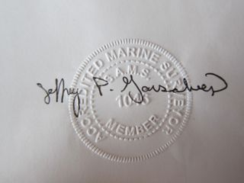
7.10.2018 #1048

Mr. Johan Hedlund
23 Butterville Road
New Paltz, NY 12561-2800

INSPECT VESSEL, CONDUCT SEA TRIAL AND PREPARE REPORT

$22/ft @ 55’ - $1210.00

Paid in full – 7/9/2018

Thank You
Make check payable to:
Jeffrey P. Gonsalves
Road
South Dartmouth, MA 02748

Payment due upon receipt.

